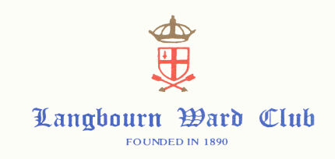

President Hon. Secretary
Alderman Sir David Wootton Ann Osler
annosler@yahoo.com
01483 504496
07903178782

Chairman 2019 Mr Matt Day
Programme 2019-2020

March
Friday 29th A.G.M. and Banquet - Guildhall 6.00 pm.

April
Thursday 25th Committee Meeting

May
Wednesday 8th May Visit to Lincoln’s Inn TBC

June
Thursday 6th Committee Meeting
Friday 21st Civic Lunch - Bakers' Hall 12.15 for 1.00 pm.

July
Wednesday 10th Bowls Evening – Finsbury Square

August
Saturday 10th Tour of the National Maritime Museum – 1.00 am

September
Saturday 7th Imperial War Museum -11.00 am
Thursday 12th Committee Meeting

October
Monday 21st Guided Tour of Two Temples10.00 am

November
Saturday 2nd Visit to Tate Modern -12.00 pm
Thursday 14th Committee Meeting

December
Tuesday 10th Carol Service- St Mary Woolnoth 5.45 pm

January
Saturday 11th Tutankhamun Exhibition – Saatchi Gallery 11.00 am
Thursday 16th Committee Meeting

